1. C**reate a Javascript code to generate a multiplication table asking the user to enter number of rows and columns. Use javascript function.**

**2. Design a scientific calculator using javascript**

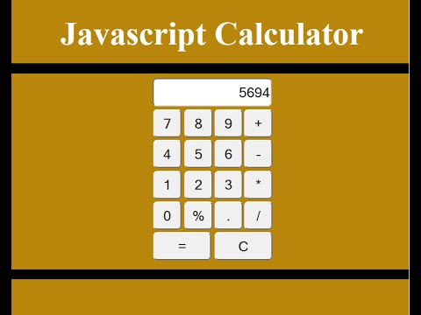

**3. Create a Javascript code to display the following table to order Pizza & on clicking confirm order following pop up box should get displayed**

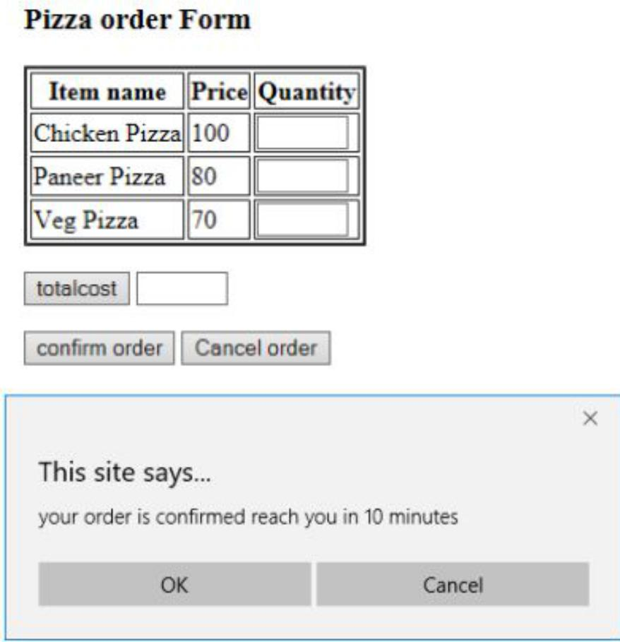

3.